Documentation Lab8

https://github.com/Aurelian-Iancu/UBB-Computer-Science/tree/main/Semester5/Formal%20Languages%20and%20Compiler%20Design/Lab8
Lex file:
%{
#include <stdio.h>
#include <stdlib.h>
#include <string.h>

int lines = 1;
%}

%option noyywrap
%option caseless

DIGIT [0-9]
NON_ZERO_DIGIT [1-9]
INT_CONSTANT [+-]?{NON_ZERO_DIGIT}{DIGIT}*|0
LETTER [a-zA-Z_ă]
SPECIAL_CHAR [ ?:*\^+=.!]
STRING_CONSTANT (\"({LETTER}|{DIGIT}|{SPECIAL_CHAR})*\")
IDENTIFIER {LETTER}({LETTER}|{DIGIT})*
BAD_IDENTIFIER ({DIGIT})+({LETTER})+({LETTER}|{DIGIT})*

%%

"vector"|"char"|int|"string"|"bagă"|"arată"|"oare"|"altfel"|"atunci"|"cattimp"|"fă"|"start"|"oftype" {printf("%s - reserved word\n", yytext);}

"+"|"-"|"*"|"/"|"=="|"<"|">"|"<="|">="|"mod"|"=" printf("%s - operator\n", yytext);

{IDENTIFIER} {printf("%s - identifier\n", yytext);}

{BAD_IDENTIFIER} {printf("Error at token %s at line %d\n", yytext, lines); exit(1);}

{INT_CONSTANT} {printf("%s - integer constant\n", yytext);}

{STRING_CONSTANT} {printf("%s - string constant\n", yytext);}

"["|"]"|";"|"("|")"|"{"|"}"|"," printf("%s - separator\n", yytext);

[ \t]+ {}

[\n]+ {++lines;}

. {printf("Error at token %s at line %d\n", yytext, lines); exit(1);}

%%

int main(int argc, char** argv) {
if (argc > 1)
yyin = fopen(argv[1], "r");
else
yyin = stdin;
yylex();
}
DEMO:
First command
Second command
Third command:
We run the executable we just created with parameter the name of the file we want to scan. a.exe is the name of the executable and p1.txt is the name of the file.
The result is:
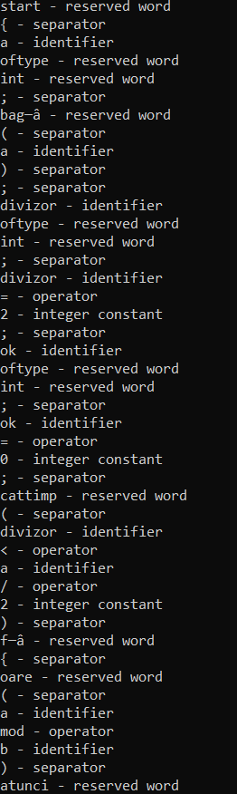
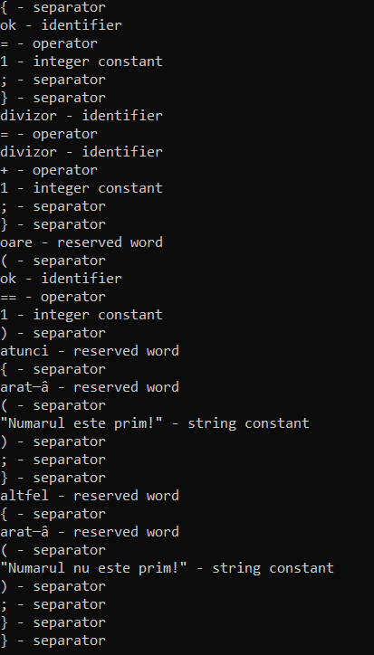

The file content of p1.txt:
start
{
a oftype int;
bagă ( a );
divizor oftype int;
divizor = 2;
ok oftype int;
ok = 0;
cattimp ( divizor < a / 2 ) fă {
oare( a mod b ) atunci {
ok = 1;
}
divizor = divizor + 1;
}

oare ( ok == 1 ) atunci {
arată ( "Numarul este prim!" );
}
altfel {
arată( "Numarul nu este prim!" );
}
}

